Software Design Document
<News and Entertainment>



Submitted by
<Ahsan Sajjad (Roll No: F22BINFT1M01172 (3M))>

Submitted to
<Ms.Kainat>

Department of Information Technology
Faculty of Computing
The Islamia University of Bahawalpur

Summary
This Software Design Document (SDD) provides a complete design overview of the News and Entertainment Website, a web-based application developed to deliver authentic news and entertainment content through a single digital platform. The purpose of this system is to allow users to access current affairs, entertainment updates, and multimedia content in an organized, responsive, and user-friendly environment.

The system is designed to support multiple users, including administrators and general users. Administrators manage news content, categories, and advertisements, while users can browse news, view entertainment content, and post comments. The document explains the system architecture, database schema, and user interface design. The proposed design emphasizes scalability, maintainability, and performance, ensuring that future enhancements can be implemented easily.

Table of Content
• Application Architecture
• Data Model Schema
• User Interface

- Application Architecture
Overview
The News and Entertainment Website is designed using a web-based client-server architecture. The system allows users to interact with the application through a web browser, while the server handles data processing, authentication, and database operations.
To maintain a clear separation of concerns, the system follows the Model–View–Controller (MVC) architectural pattern.

MVC Architecture Description
Model
The Model component represents the business logic and database layer of the system. It is responsible for handling data storage, retrieval, and updates.
Proposed Models:
- User
- News
- Category
- Comment
- Advertisement
Each model corresponds to a database table and ensures data integrity and consistency.

View
The View component is responsible for displaying data to the users. It consists of web pages developed using HTML, CSS, and JavaScript. Views receive data from controllers and present it in a readable and interactive format.
Examples of views include:
- Home page
- News detail page
- Category page
- Login and registration page
- Admin dashboard

Controller
Controllers act as a bridge between Models and Views. They receive user requests, process the logic, interact with the models, and return appropriate views.
List of Controllers and Functions:
UserController
- registerUser(): Registers a new user
- loginUser(): Authenticates user credentials
- logoutUser(): Ends user session
- manageProfile(): Updates user profile information
NewsController
- addNews(): Adds new news content
- updateNews(): Updates existing news
- deleteNews(): Removes news
- viewNews(): Displays news details
- searchNews(): Searches news by keywords
CategoryController
- addCategory(): Creates a new category
- updateCategory(): Updates category information
- viewCategory(): Displays category-wise news
CommentController
- addComment(): Adds user comments
- deleteComment(): Removes inappropriate comments
AdminController
- manageUsers(): Controls user access
- approveNews(): Approves news before publishing
- manageAdvertisements(): Controls advertisements

APIs and External Libraries
- Internal APIs are used for CRUD operations related to news, users, and comments.
- External libraries include:
  - Bootstrap for responsive UI design
  - JavaScript libraries for dynamic behavior

UML Diagrams
Class Diagram Explanation
The class diagram represents the structure of the system by showing classes, their attributes, methods, and relationships. Major classes include User, News, Category, Comment, and Advertisement. Relationships such as one-to-many between User and News and Category and News are clearly defined.
Sequence Diagram Explanation
The sequence diagram illustrates the interaction between a user and the system. For example, when a user views a news article, the request is sent to the NewsController, which retrieves data from the News model and returns it to the View for display.

Coding Conventions
- MVC folder structure
- Proper naming conventions
- Code indentation and comments
- Secure authentication and validation

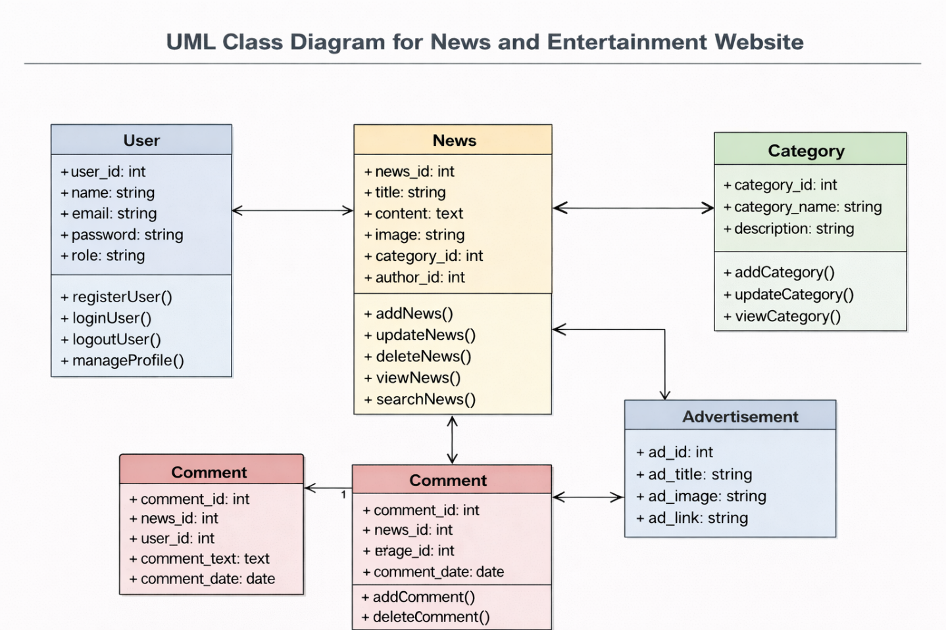

- Data Model Schema

Database Overview
The system uses a relational database to store structured data securely and efficiently.

Entities and Attributes
User
- user_id (Primary Key)
- name
- email
- password
- role (Admin/User)
- created_at
News
- news_id (Primary Key)
- title
- content
- image
- category_id (Foreign Key)
- author_id (Foreign Key)
- publish_date
Category
- category_id (Primary Key)
- category_name
- description
Comment
- comment_id (Primary Key)
- news_id (Foreign Key)
- user_id (Foreign Key)
- comment_text
- comment_date
Advertisement
- ad_id (Primary Key)
- ad_title
- ad_image
- ad_link
- status

Relationships
- One user can publish multiple news articles
- One category can contain many news articles
- One news article can have multiple comments
- One user can post multiple comments

ER Diagram Explanation
The ER diagram visually represents entities and their relationships. Primary keys uniquely identify each entity, while foreign keys establish relationships between tables. This structure ensures data integrity and eliminates redundancy.

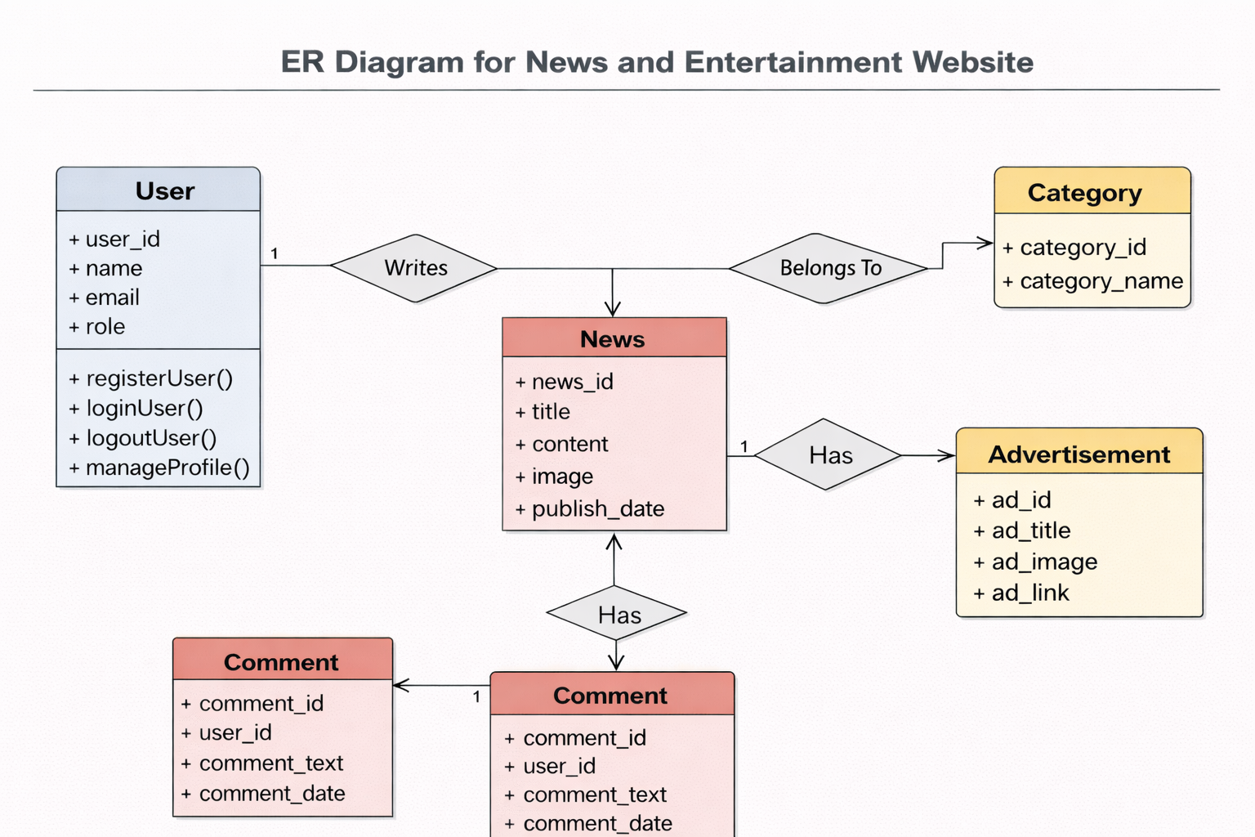

- User Interface
Design Philosophy
The interface follows a clean, modern, and responsive design philosophy. The focus is on readability, easy navigation, and fast access to content.

Target Screen Sizes
- Desktop
- Tablet
- Mobile

Screens and Controls
Home Page
Displays latest news and entertainment content.
Controls:
- Navigation bar
- Search bar
- Category menu
- News cards

News Detail Page
Displays full news content along with comments.
Controls:
- Text content
- Comment input box
- Submit button

Category Page
Displays category-specific news.
Controls:
- News list
- Filter options

Login / Registration Page
Controls:
- Email textbox
- Password textbox
- Login/Register buttons

Admin Dashboard
Allows administrators to manage the system.
Controls:
- Data tables
- Forms
- Action buttons

Input Constraints
- Mandatory fields validation
- Email format validation
- Password length constraints

Conclusion
The News and Entertainment Website is designed to provide a reliable and scalable platform for delivering news and entertainment content. The MVC architecture, well-structured database schema, and responsive user interface ensure high performance, security, and maintainability. This Software Design Document serves as a comprehensive guide for system development and future enhancements.

